Easter Holiday Club

A great opportunity for your child to interact with other children aged 3-11. Engage in social interactions they may have been missing out on! All while participating in fun filled activities, in a safe environment, with friendly and energetic staff.

WEEK 1

Monday 5th April
BANK HOLIDAY
Tuesday 6th April
Easter Day
Come join us for an egg hunt and Easter crafts.

Wednesday 7th April
Ice Cream Sundaes
Choose your favourite ice cream and load it up with sauce and toppings.
Thursday 8th April
Den Building
Let’s get outside and build a den!

Friday 9th April
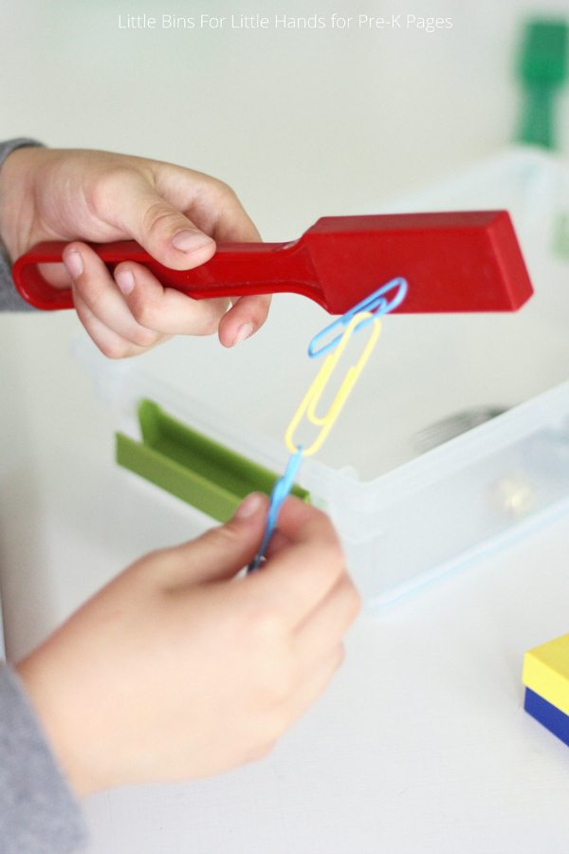
Mini Scientists
Get ready to have fun with magnets, explore colours and more.

WEEK 2
Monday 12th April
Jr Bake Off
Get your apron ready and lets see who can make the funniest pizza!
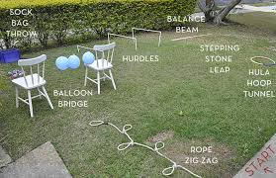
Tuesday 13th April
Competition Day
From egg and spoon races to obstacle courses join us for different challenges throughout the day.
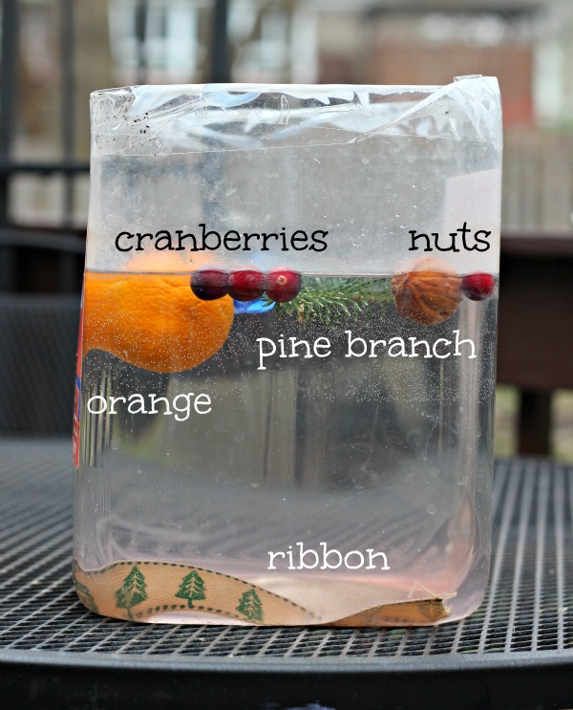
Wednesday 14th April
Mini Scientists
Come find out what sinks and floats, explore static electricity and more!

Thursday 15th April
Movie Afternoon
Grab some snacks, a drink and your friends and come chill out with a movie.
Friday 16th April
Talent Show
Everyone’s got a hidden talent, come and show off yours.

The above are different activities that will be offered. These activities are subject to change and we hope to be able to add more trips if lockdown restrictions allow and therefore some activities may not go ahead as stated. If so we will prosper to complete these activities on a different day. As well as these activities we will also provide toys, video games, crafts, colouring, outside play etc as normal throughout the day.

